1. Introduction to Animal Biology *Chapters 1, 31, 38*

______________________________________________________________________________

I. Organizing Biodiversity: the Three Domains of Life *(009-014)*

II. Characteristics of Animals *(706-708)*

A. Cellular Characteristics

# B. Organismal Characteristics

III. Animal Diversity: Body Plans and Complexity *(708-713)*

A. Phylogenetic Trees

1. Definition

2. Understanding animal diversity

B. Subkingdoms of Animals

1. Parazoa

2. Eumetazoa

C. Branches of the Subkingdom Eumetazoa

1. Radiata

2. Bilateria

D. Body Plans and Body Cavities

01-1

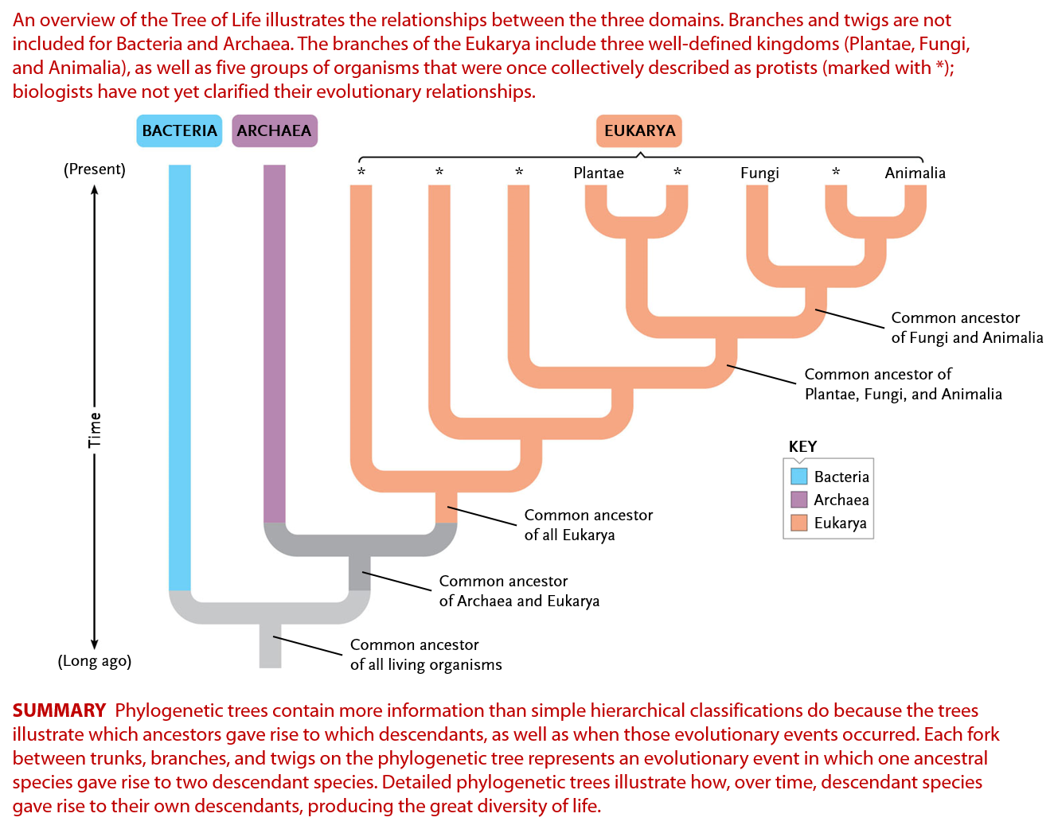

01-2

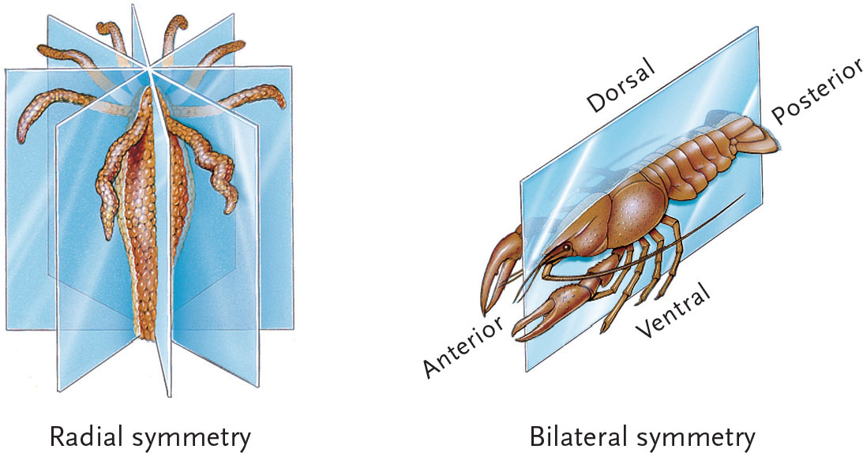

________________________________________________________________________

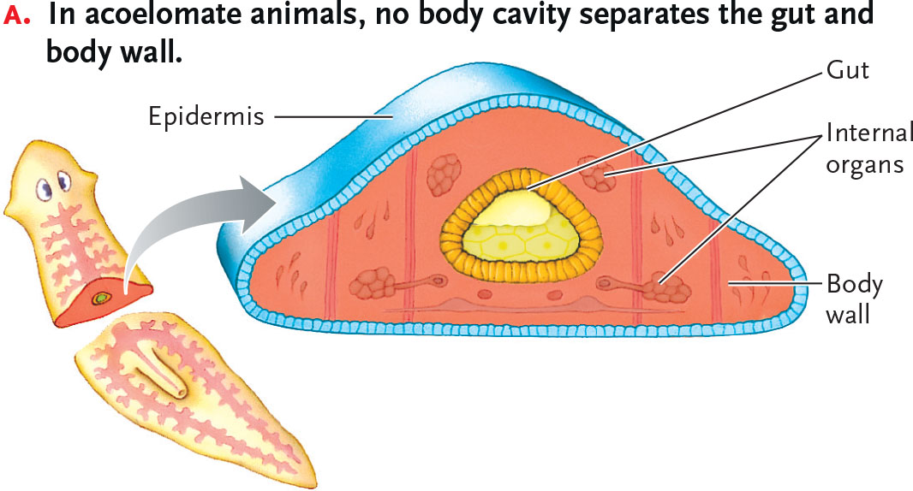

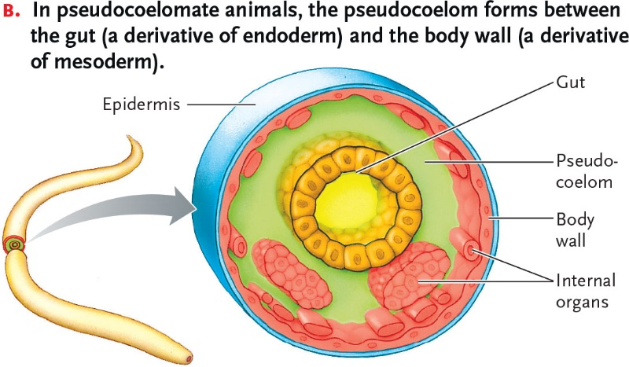

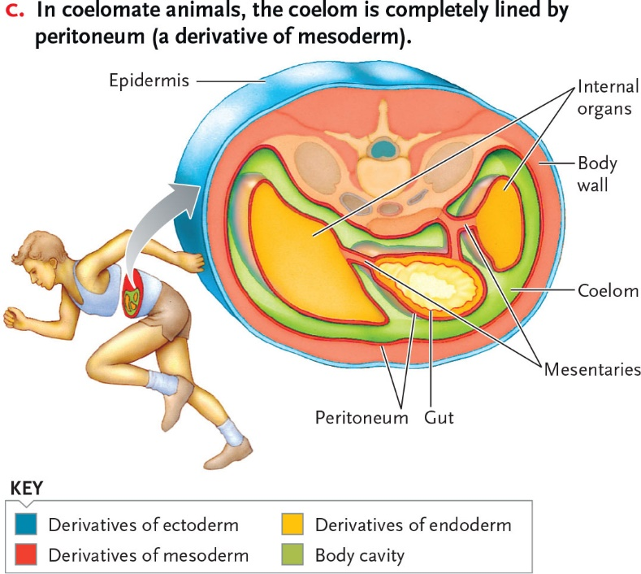

01-3

